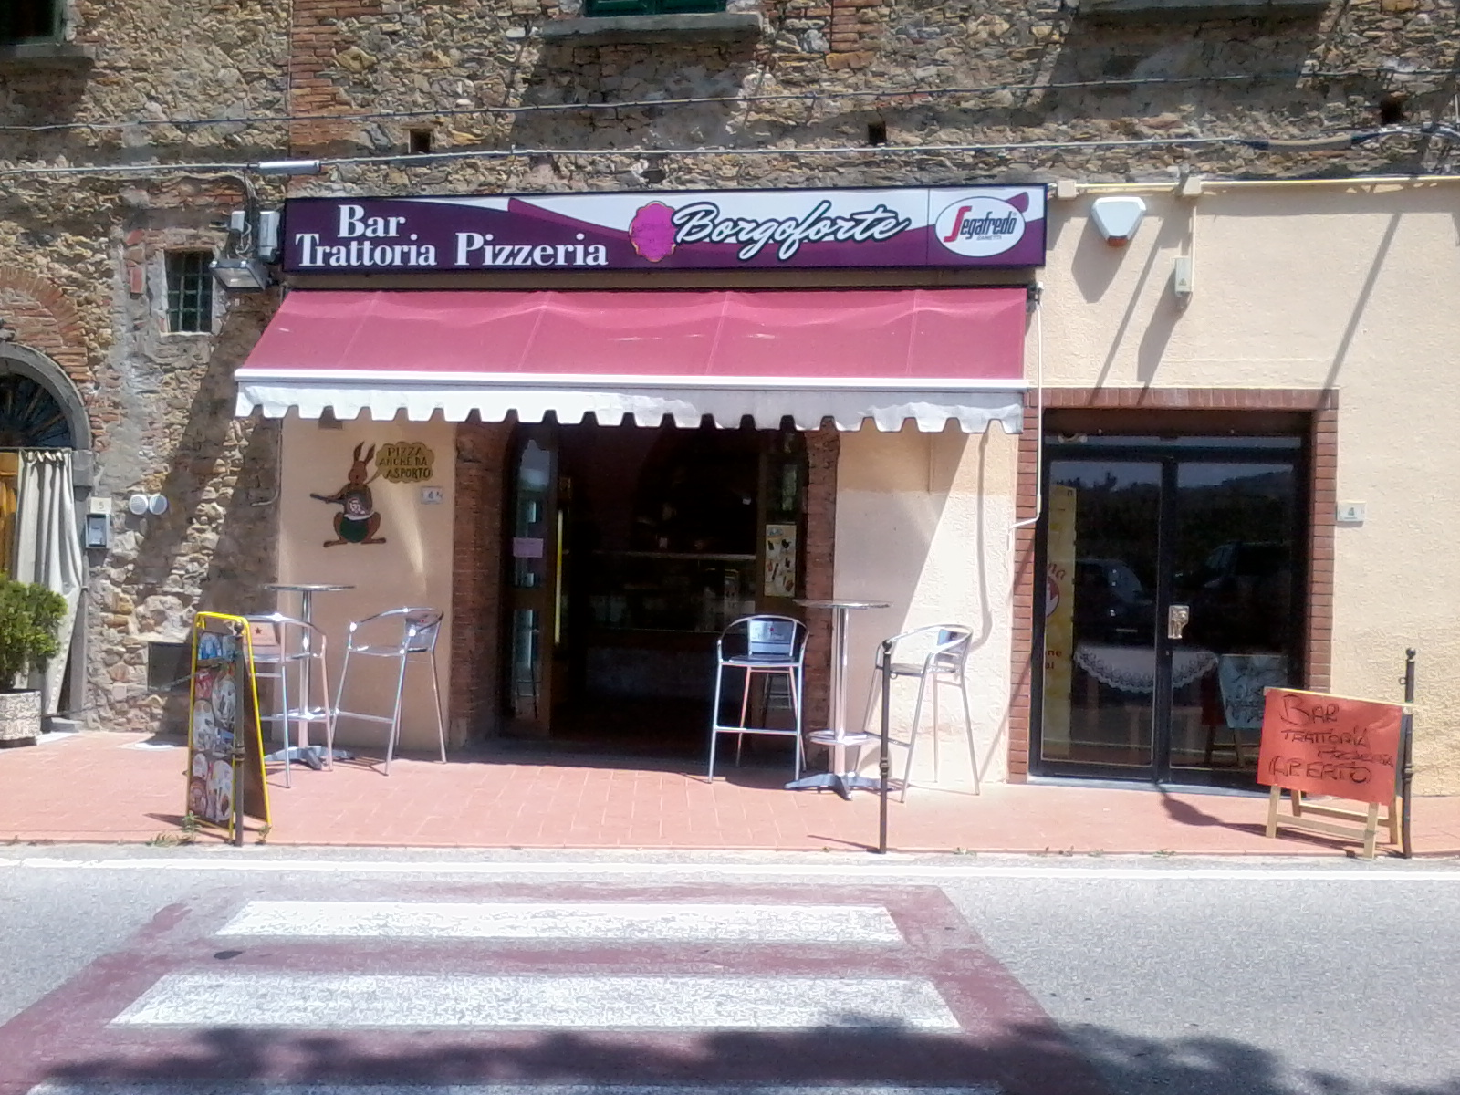

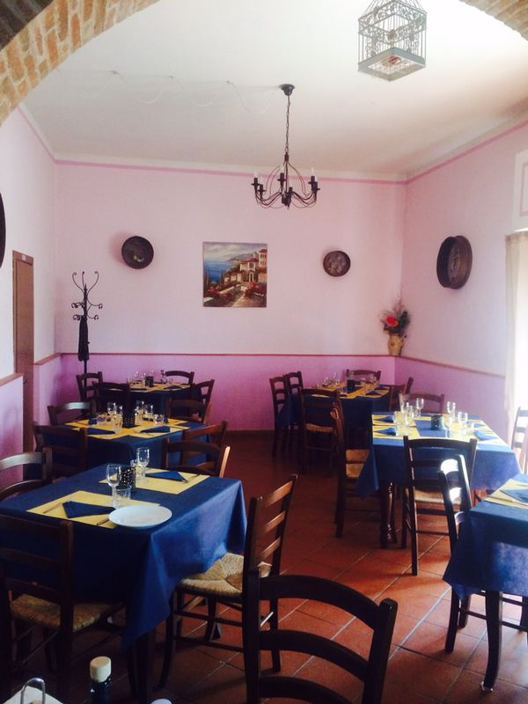
STARTERS

-Mix hors € 10,00
-Mixed bruschetta € 6,00
-Ham and melon € 8,00
-Platter of cheeses and jams € 9,00
-Mozzarella with tomato and basil € 5,00

SEA FOOD APPETIZER

-Mix of sea of Borgoforte € 12,00
-Mussel soup € 9,00
-Shrimp, e Arugula and parmesan € 8,00
-Mussels Brandy € 8,00

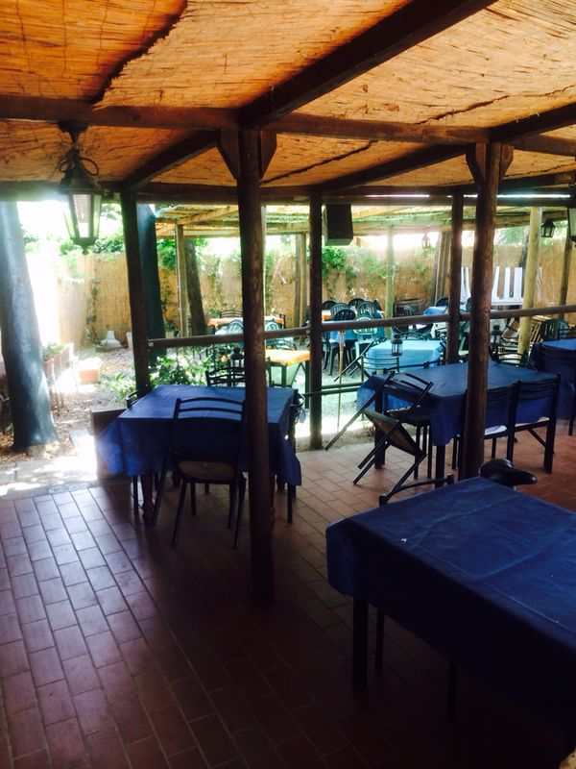
FIRST COURSES

-Malfatti pasta butter and sage € 8,00
-Pappardelle pasta with wild boar € 7,00
-Ravioli pasta with ragù porcini and wainuts € 8,00
-Penne pasta with cream of zucchini € 7,00

FIRST DISHES OF SEA

-Pasta with mix of fish and crustaceans € 10,00
-Spaghetti pasta with clams € 9,00
-Butterfly pasta with shrimps pumpkins and
saffron € 9,00

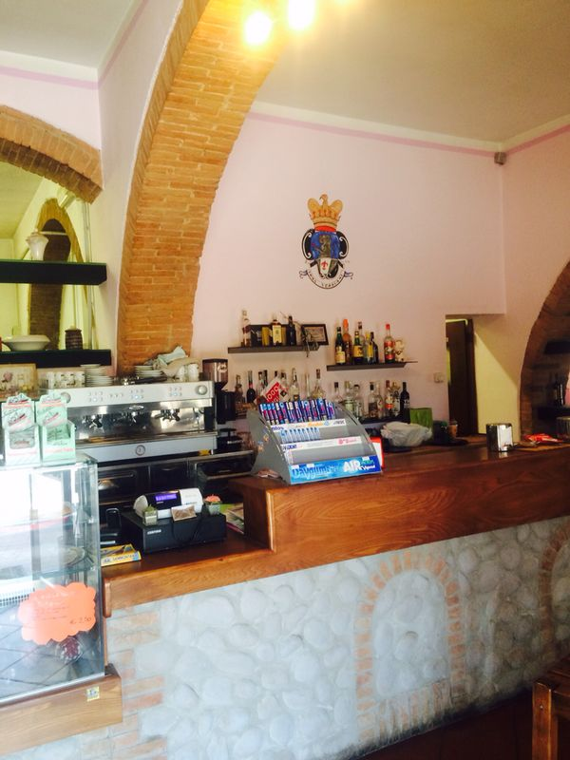
SECOND COURSES

-Stripe of beef with vegetables € 15,00
-Stripe of “Angus” argentine beef € 16,00
-Lamb chops with herbs € 13,oo
-Beefsteak on grill hg € 3,50
-Stripe of pork with lard-typical Tuscan salami € 13,00
-Pork tenderloin with pumpkins and eggplant € 14,00

MAIN COURSES OF FISH

-Mix of fry fish € 12,00
-Prawns in sweet and strong € 12,00
-Catalan of crustaceans with vegetables € 16,00
-Shrimp to the stew € 16,00
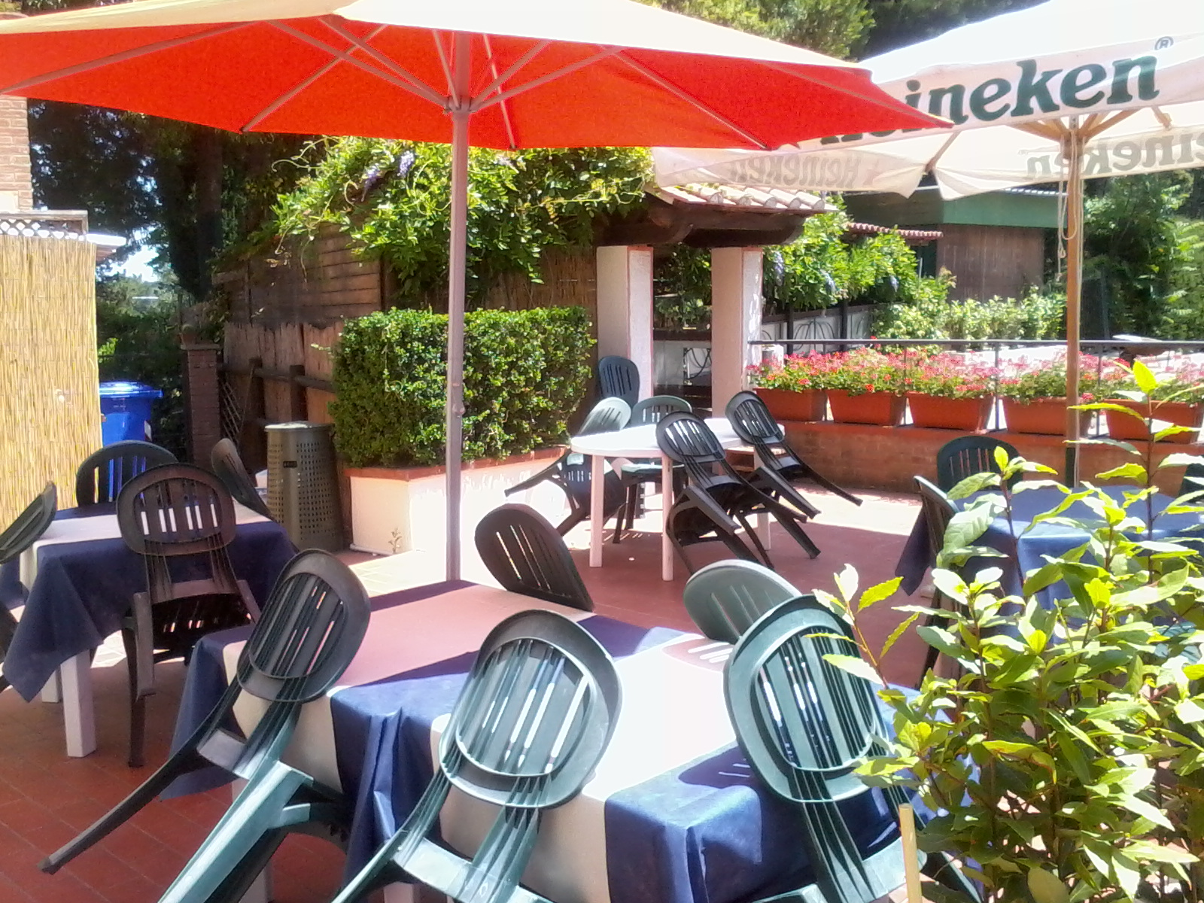
CONTOURS

-French fries € 3,oo
-Mixed salad € 3,00
-With beans € 3,00
-Grilled vegetables € 4,00
-Sautéed spinach € 3,oo
DESSERT
-Ask the waitress € 4,00

PIZZE
-Pizza’s at your pleasures

